North South University  
CSE 225L: Data Structure Lab

Final Assignment

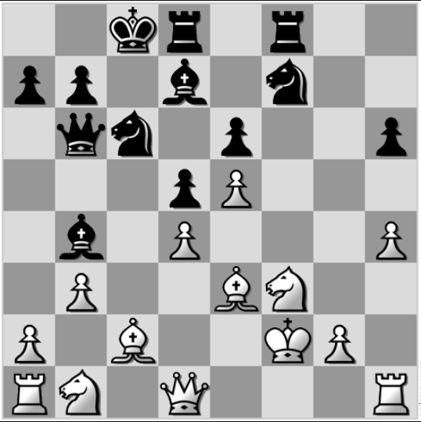

Suppose, this is the current position of the game. You are belong to white team. Let’s just think you are expert using knight. In this situation, you are thinking you will attack the opponent with your knight. You are thinking to calculate the shortest move for each pieces of the opponent from any of your knight. Show all the shortest move to capture all the pieces of the opponent. You also have to mention the piece name when you print the shortest move to capture that piece.

**Description-**

To solve that problem, you have to take user inputs for each position of the each piece of the opponent. Based on this picture, there are 12 pieces extant of the opponent team (Black). So, you will take a user input to know that how many extant pieces are there of the opponent.

Then, you have to take 12 user inputs for those positions. For example, here the positions of two rooks of the opponent team are – (0, 3) and (0, 5).

For each piece of the opponent, you can assign a different value to recognize that particular piece.

For example,

|  |  |  |  |  |  |
| --- | --- | --- | --- | --- | --- |
| King – 1 | Queen- 2 | Rooks – 31, 32 | Knights – 41, 42 | Bishops- 51, 52 | Pawns – (61 – 68) |

(You can take any value based on your preference)

Now, you will take the positions of your pieces by user inputs. (You don’t have to assign any value for your pieces).

After that, you will take a user input of the position of your knight to mention the source to find the shortest move. (Only one will be enough for this task)

Then, you have to calculate the shortest move to capture for all the 12 existing pieces. (For this example, 12 pieces, but it will depend on the user input)

|  |  |
| --- | --- |
| Here, to capture the pawn you have to take at least 2 moves.  So, for this particular piece, you have to print, **pawn1 = 2** | Here, to capture the knight you have to take at least 2 moves.  You have to print,  **Knight1 = 2** |
|  |  |

**You have to show the shortest move to capture for all the 12 existing pieces of the opponent.**

Point to be noted, you will get to know the pieces’ names based on the value you have assigned for each piece.